Scheduled Message Sending
Client User Guide
Server MTM Programmers Guide

Owner: | Anthony Alexander
Created: | 16 Nov 1999
Last Reviewed: | 1 Mar 2002
Revision: | 0.07
Status: | Draft
Contributers: | Anthony Alexander
Distribution:
Network Location:
Perforce Location: | \\EPOC\main\generic\msg\schsend\docs\Documents\SCHSEND User and Programmer Guide.doc

Revision History

Date | Author | Reason
1/3/2002 | Anthony Alexander | Added section "3.2 Resource File Format". Did not modify any other section.

1. Introduction 3
1.1 Purpose and Scope 3
1.2 References 3
2. Client User Guide 4
2.1 Scheduling Messages 4
2.1.1 Settings Classes 4
2.1.2 Each Message 4
2.1.3 Call InvokeAsyncFunctionL() / TransferCommandL() 5
2.1.4 The Messages are Now Scheduled! 5
2.2 Deleting a Schedule (Un-Scheduling) 7
2.2.1 Call InvokeAsyncFunctionL() / TransferCommand() 7
2.2.2 Messages are Now Un-Scheduled 7
2.3 Checking the Schedule 9
2.3.1 Call InvokeAsyncFunctionL() / TransferCommand() 9
2.3.2 The Schedule is Now Checked 9
2.4 Re-Scheduling Messages 11
3. Server MTM Programmer’s Guide 12
3.1 Checklist 12
3.1.1 Implement a Class Derived from CMsvScheduledEntry 12
3.1.2 Implement a Class Derived from CMsvScheduleSend 12
3.1.3 Create Command IDs for Scheduling 12
3.1.4 Derive the Server MTM from CScheduleBaseServerMtm 12
3.1.5 Implement the CScheduleBaseServerMtm Pure Virtual Functions 12
3.1.6 Construct the CMsvScheduleSend-Derived Class and call RestoreScheduleSettingsL() in the Server MTM 13
3.1.7 Add Cases to the Server MTM StartCommandL() for Scheduling 13
3.1.8 (Optional) Modify the Sending Code so it Re-Schedules 13
3.1.9 (Optional) Add Send Error Actions to the Server MTM Resource File 13
3.2 Resource File Format 14
3.2.1 Resource struct SEND_ERROR_ACTIONS 14
3.2.2 SchSend.rh 14
3.2.3 SchSend.hrh 14
3.3 Sequence Diagrams 16
3.3.1 How a Messages are Scheduled 16
3.3.2 How Scheduled Messages are Sent 17

Introduction

Purpose and Scope
This purpose of this document is to :
- Outline and demonstrate how a client (e.g., an editor) can schedule messages on a Server MTM, and;
- Describe how to write a Server MTM that supports scheduling.

By the end of the document you should be able to:
- Schedule messages (e.g faxes or SMSs).
- Delete the schedule of a selection of messages.
- Check the schedule of a selection of messages.
- Write a Server MTM that supports scheduling.

Specific examples are given on how to schedule a fax and SMS, as these are the first Server MTMs that will support scheduling.

References
 | Document | Date | Rev | Author/Owner
1. | Scheduled Message Sending  Requirements and  Functional Specification | 16/11/1999 | 0.5 | Anthony Alexander

Client User Guide

Scheduling Messages
Perform the following three (3) steps to schedule messages with an MTM that supports scheduling. Fax and SMS specific examples are provided.

When complete the messages will be scheduled on the Task Scheduler.

Settings Classes
You need to make sure the schedule settings for the MTM are set to your desired values before attempting to schedule any messages. There are three (3) classes of settings:

- General scheduling settings, found in CMsvScheduleSettings;
- Off-Peak times, found in CMsvOffPeakTimes;
- The System Agent conditions that must be satisfied before a sending attempt, found in CMsvSysAgentActions; and
- The actions to take if certain errors occur during sending, found in CMsvSendErrorActions.

Fax Specific
For fax you only need to worry about the first three (3) settings classes (above), as the CMsvSendErrorActions is stored in the Fax Server MTM resource file.

The CMsvScheduleSettings, CMsvOffPeakTimes and CMsvSysAgentActions are stored in streams of the same store as the general fax settings. Use the StoreL and RestoreL functions of these classes to manipulate the settings.

SMS Specific
For SMS you only need to worry about the first three (3) settings classes (above), as the CMsvSendErrorActions is stored in the SMS Server MTM resource file.

The CMsvScheduleSettings, CMsvOffPeakTimes and CMsvSysAgentActions are stored in streams of the same store as the general SMS settings. Use the StoreL and RestoreL functions of these classes to manipulate the settings.

Each Message
You may schedule a selection of messages. Before they can be scheduled, two members of the associated TMsvEntries must be set.

The following table outlines which data in the TMsvEntry you need to set:

Member / Function | Value
iDate | Time you want the message scheduled. If this member is in the past by the time it reaches the Server MTM then the message is scheduled for now plus CMsvScheduleSettings::Latency().
SetOffPeak() | ETrue if you want the message sent OffPeak, otherwise EFalse (may not be supported by some MTMs).

Note: If you are scheduling more than one message, all TMsvEntrys identified in the CMsvEntrySelection must have the same iDate and OffPeak() value.

Fax Specific
The Fax MTM does not support Off-Peak sending.

SMS Specific
The SMS MTM does not support Off-Peak sending.

Call InvokeAsyncFunctionL() / TransferCommandL()
After the messages have been prepared for scheduling you need to call the Client MTM InvokeAsyncFunctionL()or CMsvSession::TransferCommandL().

Pass the following values to (either of) these functions:

Argument | Value
TInt aFunctionId | The MTM specific scheduling function ID (unfortunately there is no single function ID for scheduling that is shared by all MTMs). This may be different if you are performing a move or copy.
CMsvEntrySelection& aSelection | The selection of messages you would like to schedule. Each TMsvEntrys identified in aSelection must have the same iDate and OffPeak() value.
TDesC8& aParameter | The MTM specific parameter for sending.

Currently all scheduling is synchronous, and is expected to complete (reasonably) quickly.

Fax Specific
Pass the following values to the Fax Client MTM InvokeAsyncFunctionL() or CMsvSession::TransferCommandL() to schedule faxes:

Argument | Value
TInt aFunctionId | KFaxMTMScheduleCopy or KFaxMTMScheduleMove
CMsvEntrySelection& aSelection | The selection of messages you would like to schedule. Each TMsvEntrys identified in aSelection must have the same iDate and OffPeak() value.
TDesC8& aParameter | Either nothing (just pass TPtrC8()) or a packaged TFaxRenderParameters.

SMS Specific
Pass the following values to the SMS Client MTM InvokeAsyncFunctionL() or CMsvSession::TransferCommandL() to schedule SMSs:

Argument | Value
TInt aFunctionId | ESmsMtmCommandSendScheduledCopy or ESmsMtmCommandSendScheduledMove
CMsvEntrySelection& aSelection | The selection of messages you would like to schedule. Each TMsvEntrys identified in aSelection must have the same iDate and OffPeak() value.
TDesC8& aParameter | Nothing (just pass TPtrC8()).

The Messages are Now Scheduled!
If a message was is successfully scheduled on the Task Scheduler, members of the TMsvEntry will be set to the following value:

Member / Function | Value
iDate | The actual time the message was scheduled for.
Scheduled() | ETrue
SendingState() | KMsvSendStateScheduled

If a message failed to be scheduled on the Task Scheduler, members of the TMsvEntry will be set to the following value:

Member / Function | Value
iDate | Unchanged
Scheduled() | EFalse
SendingState() | KMsvSendStateUnknown

Deleting a Schedule (Un-Scheduling)
Perform the following step to remove the entry for a message from the Task Scheduler.

Call InvokeAsyncFunctionL() / TransferCommand()
Call the Client MTM InvokeAsyncFunctionL()or CMsvSession::TransferCommandL(), and pass the following values to (either of) these functions:

Argument | Value
TInt aFunctionId | The MTM specific delete schedule function ID (unfortunately there is no single function ID for scheduling that is shared by all MTMs).
CMsvEntrySelection& aSelection | The selection of messages that you would like to un-schedule. It is not a pre-condition that each message is already scheduled.
TDesC8& aParameter | Nothing (just pass TPtrC8()).

Fax Specific
Pass the following values to the Fax Client MTM InvokeAsyncFunctionL() or CMsvSession::TransferCommandL() to un-schedule faxes:

Argument | Value
TInt aFunctionId | KFaxMTMDeleteSchedule
CMsvEntrySelection& aSelection | The selection of messages that you would like to un-schedule. It is not a pre-condition that each message is already scheduled.
TDesC8& aParameter | Nothing (just pass TPtrC8()).

SMS Specific
Pass the following values to the SMS Client MTM InvokeAsyncFunctionL() or CMsvSession::TransferCommandL() to un-schedule SMSs:

Argument | Value
TInt aFunctionId | ESmsMtmCommandDeleteSchedule
CMsvEntrySelection& aSelection | The selection of messages that you would like to un-schedule. It is not a pre-condition that each message is already scheduled.
TDesC8& aParameter | Nothing (just pass TPtrC8()).

Messages are Now Un-Scheduled
If the entry for a message is successfully removed from the Task Scheduler, or the message was not scheduled in the first place, members of the TMsvEntry will be set to the following value:

Member / Function | Value
iDate | Unchanged
Scheduled() | EFalse
SendingState() | KMsvSendStateUnknown

If the entry for a message was not removed from the Task Scheduler, members of the TMsvEntry will be set to the following value:

Member / Function | Value
iDate | Unchanged
Scheduled() | Unchanged
SendingState() | (Should be) unchanged.

Checking the Schedule
At any time you can check what time a message is scheduled for. The iDate and Scheduled() members of the TMsvEntry will be updated with the current schedule details. The SendingState() member will remain unchanged. Perform the following step to check the schedule of messages.

Call InvokeAsyncFunctionL() / TransferCommand()
Call the Client MTM InvokeAsyncFunctionL()or CMsvSession::TransferCommandL(), and pass the following values to (either of) these functions:

Argument | Value
TInt aFunctionId | The MTM specific check schedule function ID (unfortunately there is no single function ID for scheduling that is shared by all MTMs).
CMsvEntrySelection& aSelection | The selection of messages that you would like to check the schedule for. It is not a pre-condition that each message is already scheduled.
TDesC8& aParameter | Nothing (just pass TPtrC8()).

Fax Specific
Pass the following values to the Fax Client MTM InvokeAsyncFunctionL() or CMsvSession::TransferCommandL() to check the schedule of faxes:

Argument | Value
TInt aFunctionId | KFaxMTMCheckSchedule
CMsvEntrySelection& aSelection | The selection of messages that you would like to check the schedule for. It is not a pre-condition that each message is already scheduled.
TDesC8& aParameter | Nothing (just pass TPtrC8()).

SMS Specific
Pass the following values to the SMS Client MTM InvokeAsyncFunctionL() or CMsvSession::TransferCommandL() to check the schedule of SMSs:

Argument | Value
TInt aFunctionId | ESmsMtmCommandCheckSchedule
CMsvEntrySelection& aSelection | The selection of messages that you would like to check the schedule for. It is not a pre-condition that each message is already scheduled.
TDesC8& aParameter | Nothing (just pass TPtrC8()).

The Schedule is Now Checked
If the message is scheduled on the Task Scheduler, members of the TMsvEntry will be set to the following value:

Member / Function | Value
iDate | The time the message is scheduled for
Scheduled() | ETrue
SendingState() | Unchanged

If the message is not scheduled on the Task Scheduler, members of the TMsvEntry will be set to the following value:

Member / Function | Value
iDate | Unchanged
Scheduled() | EFalse
SendingState() | Unchanged

Re-Scheduling Messages
If you wish to change the time a message is scheduled simply schedule it again for the new time. The original schedule will automatically be deleted.

Server MTM Programmer’s Guide

Checklist
You will need to perform all of the following steps to add scheduling support to a Server MTM. The last two steps are optional, though have been performed for fax.

Implement a Class Derived from CMsvScheduledEntry

CFaxScheduleEntry Declaration
class CFaxScheduledEntry : public CMsvScheduledEntry
{
public:
// --- Factory ---

static CFaxScheduledEntry* NewL(const TMsvEntry& aEntry);

// --- Destruction ---

~CFaxScheduledEntry();

// --- From CMsvScheduledEntry ---

TBool CanSendToAnyRecipients(TMsvSendRetries aRetries, TInt16 aMaxRetries);
void RecipientsResetRetries();
void RecipientsIncreaseRetries();

void StoreL(CMsvStore& aStore) const;
void RestoreL(CMsvStore& aStore);

private:
// --- Construction ---

CFaxScheduledEntry(const TMsvEntry& aEntry);
void ConstructL();

// --- Members ---

CFaxHeader* iFaxHeader;
};

Implement a Class Derived from CMsvScheduleSend

Create Command IDs for Scheduling

Derive the Server MTM from CScheduleBaseServerMtm

Implement the CScheduleBaseServerMtm Pure Virtual Functions

Construct the CMsvScheduleSend-Derived Class and call RestoreScheduleSettingsL() in the Server MTM

Add Cases to the Server MTM StartCommandL() for Scheduling

(Optional) Modify the Sending Code so it Re-Schedules

(Optional) Add Send Error Actions to the Server MTM Resource File

Resource File Format

Resource struct SEND_ERROR_ACTIONS
The resource STRUCT SEND_ERROR_ACTIONS defines the rescheduling action to take when there is an SMS sending error. It specifies whether and how a message is rescheduled after a sending error.

SchSend.rh
 | Explanation
STRUCT SEND_ERROR_ACTIONS
{
STRUCT default; | Single SEND_ERROR_ACTION. This is the action to take if the error code is not found in the actions[]
STRUCT actions[]; | Array of SEND_ERROR_ACTION
}
STRUCT SEND_ERROR_ACTION
{
BYTE flags; | Action to take (i.e. whether and how to reschedule) when one of the errors in "errors[]" occurs during sending. Combination of flags from SchSend.hrh.
WORD max_retries=0; | Maximum number of times to retry sending if flags contains KRetriesFixed.
STRUCT errors[]; | Array of SEND_ERROR. Array of error codes that this action applies to.
}
STRUCT SEND_ERROR
{
LONG error; | Error code
}

SchSend.hrh
These constants can be combined in the SchSend.rh STRUCT SEND_ERROR_ACTION "flags" member. The combination of the 3 groups of flags specify the action to take when an error occurs during sending.

"KAction..." group specifies whether to attempt rescheduling of this message

"KRetries..." group specifies whether to retry sending forever or a fixed number of times (for example, retry only 3 times)

"KRetrySpacing..." group is a little more tricky. It specifies the time interval between each sending attempt/retry.

By default, each sending retry is evenly spaced (e.g. every 2 mintues). However, you may choose to use "variable" spacing. The values for "variable" spacing are found in CMsvScheduleSettings::VariableIntervals()

KActionFail | DEFAULT: Message should NOT be rescheduled.
KActionRetryImmediately | Message should be rescheduled to send immediately. The time interval is taken from CMsvScheduleSettings::ShortInterval()
KActionRetryLater | Message should be rescheduled to send in the future. The time interval is taken from CMsvScheduleSettings::LongInterval()
KActionSentAlready | Message has been sent successfully and should NOT be rescheduled.
KRetriesFixed | DEFAULT: Sending will be retried X number of times, where X = max_retries in STRUCT SEND_ERROR_ACTION
KRetriesInfinite | Sending will be retried infinite/many times, until user cancels sending or sending successful.
KRetrySpacingStatic | DEFAULT: Sending retries are evenly spaced
KRetrySpacingVariable | Each retry is spaced according to the values in CMsvScheduleSettings::VariableIntervals().

Sequence Diagrams

How a Messages are Scheduled
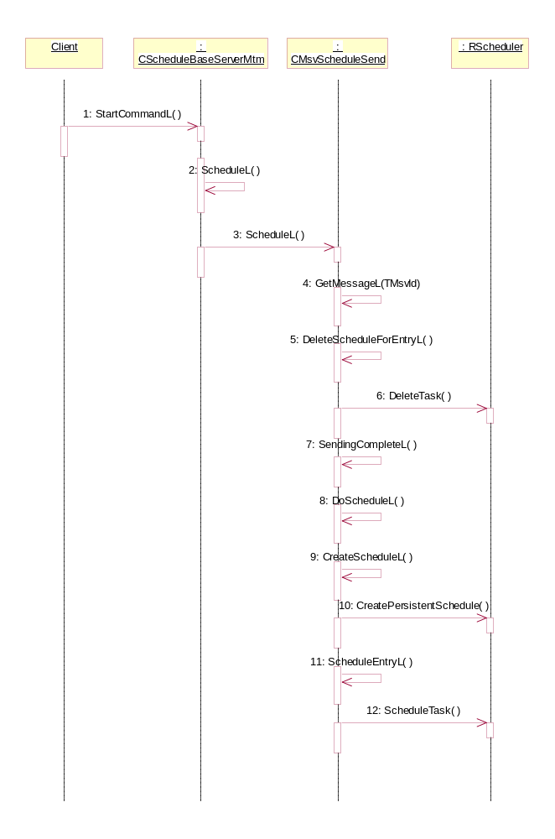

How Scheduled Messages are Sent
